YEAR 8 SCIENCE
EARTH & SPACE SCIENCES
INVESTIGATION - FORMING SHADOWS AND ECLIPSES

Activity 1 - Forming Shadows

Perform the following activity using a light box and a small opaque object such as a matchbox or block of wood.

In this activity, the distance between the light box and the screen is kept at 30 cm.

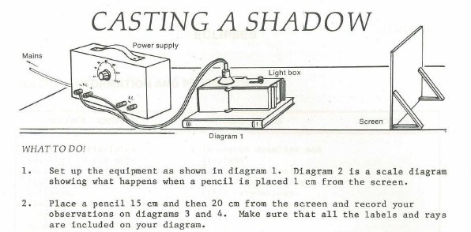

The diagrams are on the next page. Draw on them using Notability.

Things To Do

1. Find out names of the parts of the shadow. Draw labelled diagrams.

2. From the activity, can you suggest why the light sources used for night sporting
events are placed on high masts?

3. Does an aircraft flying at high altitude cast a shadow onto the Earth's surface?
Explain your answer.

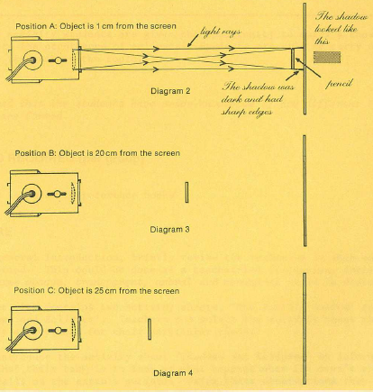

Activity 2 - Eclipses

The following diagrams show a lunar eclipse.

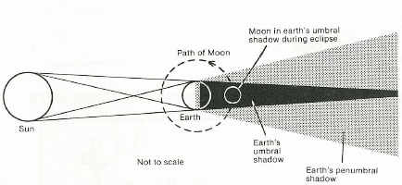

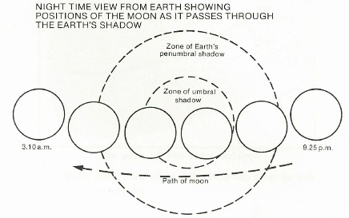

Questions

Use the diagram and map to answer questions 1 to 4.

1. Briefly describe how the eclipse shown in the diagram occurs.

2. Using an atlas mark the following cities on your map:

Nairobi, Johannesburg, Cairo, Calcutta, Delhi, Dacca and Rome.

List the cities and describe what would happen during the eclipse in each city.
3. Would people on the 'path of totality' have any warning that they were about to
experience total darkness? Explain your answer.

4. Apart from the darkness, would people on or near the 'path of totality' experience any other effects?

Using a suitable reference.

5. During a solar eclipse, many people are tempted to look at the sun. Why is this
dangerous?

6. In your own words, explain why solar eclipses are of great interest to astronomers.

7. Find out when and where the next solar eclipse will be visible in Western Australia.

